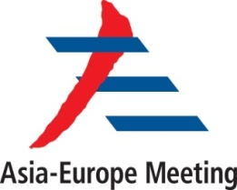 | REGISTRATION FORM  Seminar  on  Water Nexus Agenda for the Third ASEM Decade  ------------------  Ruse, Bulgaria, 1 – 3 December 2016

Country
Institution/Organization
First name
Last name
Title
Position/ Function
Office address
Attending the Seminar as | Participant: | Speaker:
Gender | Female: | Male:
Date and place of birth | Date: | Place:
Nationality
Passport No.
ID number (EU member state nationals only)
Place of issue
Date of issue
Contact Information | Tel: |  | Fax:
 | Email:
Flight Itinerary | Airport:
 | Arrival time/Flight No.
 | Departure time/Flight No.
Transport Preferences | Pick-up service: |  | Taxi/ other alternatives:
Dietary Requirement | Vegetarian: |  | Non Vegetarian:
 | Others (Please specify):
Name of hotel
Payment type | Visa Master Credit Card Debit
Card number
Registration for the field trip | Yes |  | No
Please, submit the form no later than 24 November 2016 to: brie@uni-ruse.bg

